ScheduleGalaxy App

Registration for the ScheduleGalaxy App is now open!

ScheduleGalaxy now recognizes App accounts for members of the public.

Before you download the App, go to your school’s homepage on ScheduleGalaxy.
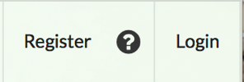
Click on the “Register” link in the top navigation bar.
A “Sign up” registration form displays.
Provide all the necessary information in the registration form.

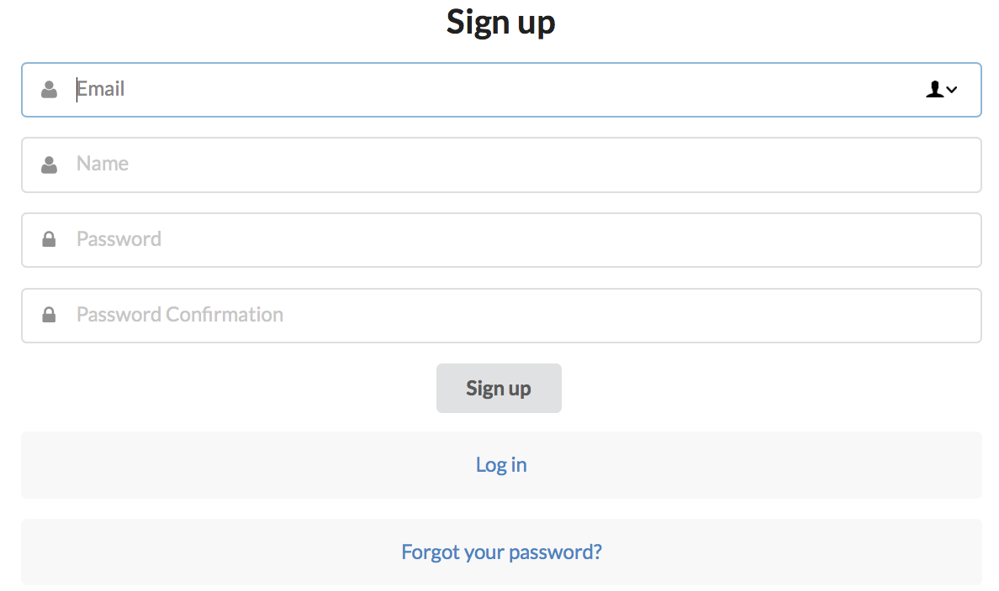

When you have successfully registered, start by selecting one
of the team schedules to which you are interested in subscribing by using the button “Subscribe to schedule” on the team schedule page.

If you want to unsubscribe from a schedule, click “Unsubscribe.”

Note that you must subscribe to each team schedule individually. Repeat the above process for each team for which you wish to subscribe on the App.
If you have previously subscribed to team alerts, once you’ve registered, those subscribed schedules will already be activated on the App and the ScheduleGalaxy site; you won’t have to subscribe again.

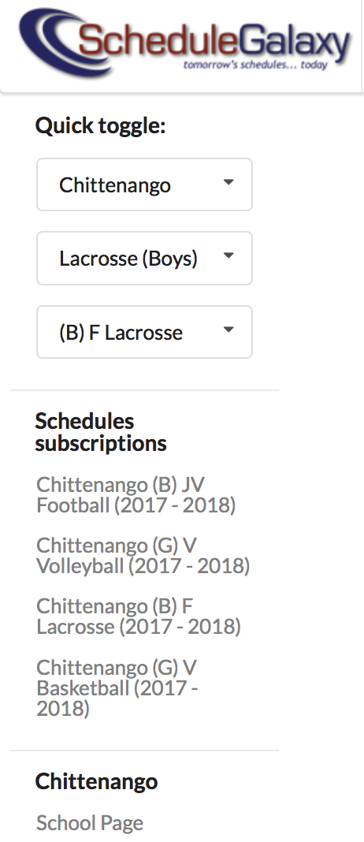
The entire list of schedules to which you are subscribed displays in the left menu.

You can quickly access your school teams from the left menu and easily manage your subscriptions.

Now, go to the App store on an Apple phone or to Google Play on an Android phone.
Download the App.

When the App is downloaded, all games of the teams that you subscribed to will be listed under the Games feature.
Click on a game to get specific game information and directions.

Once you’ve registered on your school’s ScheduleGalaxy homepage, you can also subscribe to team schedules from the App.
Pick your desired school from the list of schools under the SCHOOLS & TEAMS icon on the App.
Click on your school name in the list and all the teams your school district offers will be displayed.
Click on the Star next to the sport and team level for which you want to subscribe. The Star turns gold, meaning that you are subscribed to that team.
To unsubscribe from a team, click on the gold Star and the Star will go to white, meaning you are unsubscribed.

