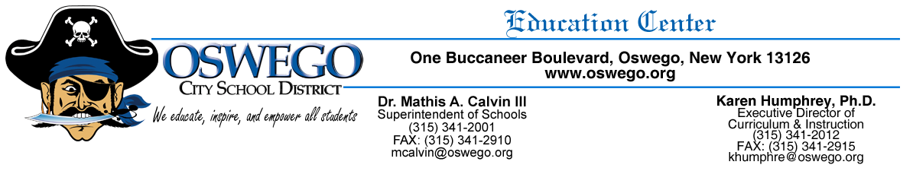

Dear Parent/Guardian,

At Oswego High School, we are very proud of our teachers and feel they are prepared to give your child a high-quality education. As a Title I school, we must meet federal rules related to teacher qualifications as defined in Every Student Succeeds Act. These rules allow you to learn more about your child’s teachers’ training and credentials. We are happy to provide this information to you. At any time, you may ask:

- Whether the teacher met state qualifications and certification requirements for the grade level and subject he/she is teaching.
- Whether the teacher received an emergency or conditional certificate through which state qualifications were waived, and
- What undergraduate or graduate degrees the teacher holds, including graduate certificates and additional degrees, and major(s) or area(s) of concentration.

You may also ask whether your child receives help from a paraprofessional. If your child receives this assistance, we can provide you with information about the paraprofessional’s qualifications.

Our staff is committed to helping your child develop the academic knowledge and critical thinking he/she needs to succeed in school and beyond. That commitment includes making sure that all of our teachers and paraprofessionals are highly skilled.

If you have any questions about your child’s assignment to a teacher or paraprofessional, please contact me at 315-341-2200.

Sincerely,
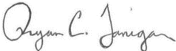

School Principal

